A new potential MAO-B Inhibitors as a treatment for Parkinson’s disease (PD)

Drug Discovery and Development

Introduction:
Parkinson’s disease (PD), described for the first time via James Parkinson in 1817, is considered the second most common neurodegenerative disorder worldwide [1]. The prevalence of PD in the USA is about 20 patients per 100,000 people per year and a total diseased, currently, of 1 million. The onset of PD, on average, is 60 years old, increasing with 1% to 3% in 80-plus years older people [2-4]. The incidence of PD is common in males more than females with 1.5 times. Also, the onset is delayed in females due to neuroprotective effect of the estrogen [5]. Parkinson's disease is characterized by motor disorders such as resting tremor, rigidity, difficulty walking, and balance problems. Some non-motor conditions are associated with PD, which are considered the prodromal phase, such as hyposmia, constipation, fatigue, depression, and sleep, incredibly rapid eye movement phase of the sleep cycle, disorders [1,6].

Etiology of Parkinson’s disease:
Parkinson's disease is a multifactorial disease; the actual cause is unknown yet, but some factors contribute to developing the disease, such as genetics and environmental factors. Genetics contributes to 10–15% of family history and 5% of Mendelian inheritance. Twenty-three genes under a family of the name "PARK'' are suspected of causing PD; some are autosomal dominant such as SNCA, LRRK2, and VPS32. SNCA, which encodes for an α-synuclein protein, has a total of five-point mutations, one discovered since 1997, and the additional four are found recently, and gene duplication or triplication. SNCA mutations are rare, unlike LRRK2 mutations, which are frequent. Six LRRK2 mutations are affirmed, including p.G2019S, which is the most common one contributing to one percent of sporadic and four percent of familial PD. Another frequent conversion related to the onset of PD is within the VPS32 gene. Some are autosomal recessive such as PRKN, PINK1, and DJ-1. The three genes encode proteins related to mitochondrial homeostasis. The essential mutation contributing to the predisposing factors of PD is the mutation within the GBA1 gene. GBA1 encodes for β-glucocerebrosidase, which is a lysosomal enzyme that hydrolyzes glucocerebrosidase. Other essential genes are genes encoding primary histocompatibility complex class II (HLA-DQB1) and tau (MAPT) [1,7]. The environmental factors include Cigarette smoking, Caffeine, herbicide, pesticides, and heavy metals. Cigarette smoking has an inverse correlation with PD, as confirmed by 44 case-control studies and eight cohort studies within a large meta-analysis, including 20 countries. The actual reason confirmed the inverse correlation is not fully understood. Still, some findings support that, including the activation of nicotinic acetylcholine receptors at the surface of dopaminergic neurons by nicotine. When applying selective agonists to PD models, they play a neuroprotective role [8,9]. Caffeine, which is an adenosine A2A receptor antagonist, has a protective effect from PD. There is a directly proportional relation between coffee drinking and protection from PD. Also, some pesticides and herbicides such as MPTP (1-methyl-4-phenyl-1,2,3,6-tetrahydropyridine), which produce a neurotoxic metabolite called MPP+ (1-methyl-4-phenylpyridinium), Paraquat, and rotenone are all damages dopaminergic cells within the substantia nigra in a selective manner through inhibiting mitochondrial complex-1 [1].
Parkinson’s disease affects Dopaminergic neurons:
Parkinson’s disease is a degenerative disease that affects the area of the brain known as the substantia nigra. Substantia nigra have dopaminergic neurons which secrete dopamine, a neurotransmitter responsible for controlled movement patterns.
In normal neurons: Dopaminergic neurons contain dopamine vesicles in the terminals, these vesicles are able to secrete dopamine and when they secrete the dopamine it will essentially either stimulate or it will inhibit these GABAergic neurons GABAergic neurons are found in the area of the brain known as a coated striatum, the coated striatum is made up of the coated nucleus and coated Putman. These areas contain GABAergic neurons which receive information from the Dopaminergic neurons from substantia nigra. So, these GABAergic neurons have dopamine receptors so that when dopamine is released it binds into these dopamine receptors and either stimulates or inhibits the GABAergic neurons. There are enzymes called Monoamine Oxidase (MAO), these enzymes essentially break down dopamine after it is being used as a sort of help in the recycling process.
In Parkinson’s disease neurons: Parkinson’s disease is where the patients have degeneration of the Dopaminergic neurons that means like no much dopamine or no dopamine being produced by the Dopaminergic neurons. These neurons in the central nervous system in the substantial nigra are surrounded and protected by the blood-brain barrier, So PD patients have decreased in dopamine in the synaptic cleft because no dopamine is being produced because the neurons are dying in addition to the presence of Monoamine Oxidase (MAO) enzymes which will still break down the dopamine if it were produced. Since the substantia nigra is a part of the region in the midbrain, this region forms part of a major pathway in the brain that is critical for facilitating movement. So, when the Dopaminergic neurons in the substantia nigra gradually die leading to the malfunction of this pathway and the characteristics of motor problems [11].
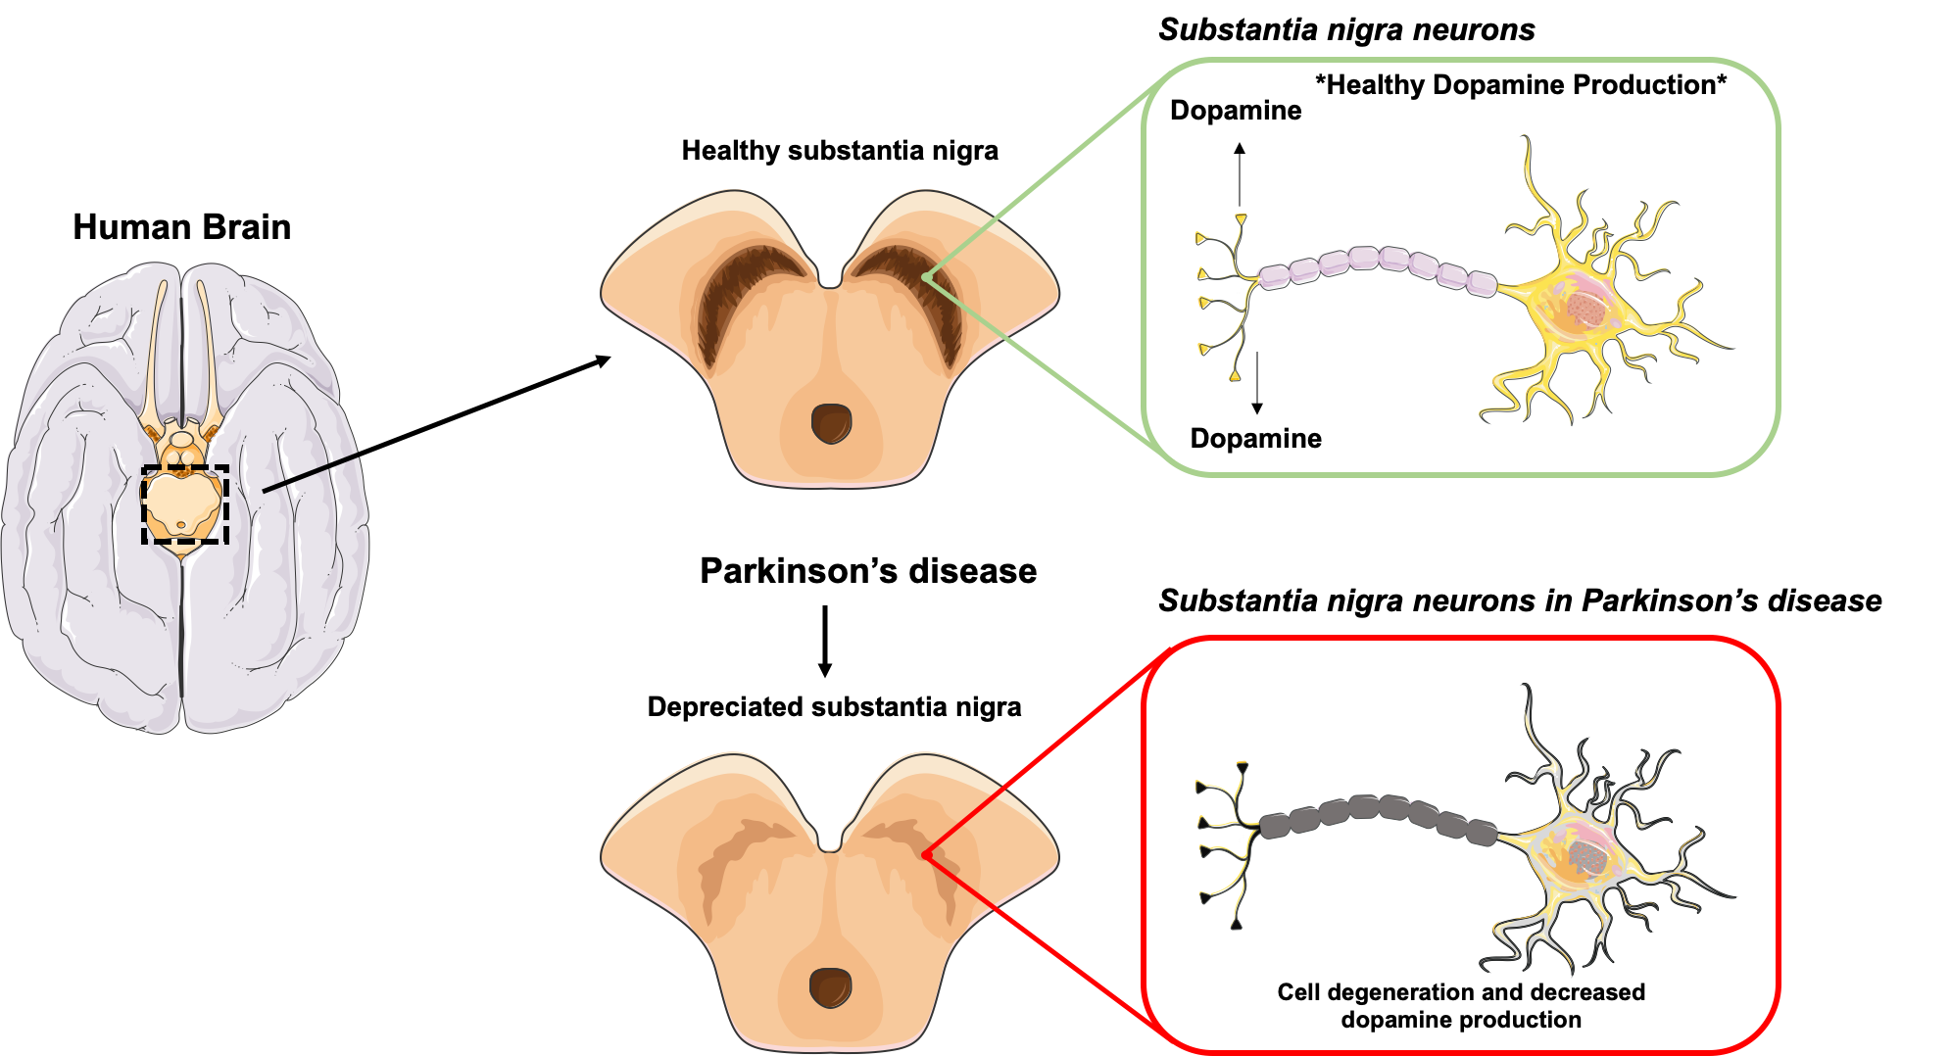

Figure 1: differences between the intact substantia nigra and the diseased, with PD, one.

Pharmacological class and mechanism of action:
Levodopa as the first line of treatment in Parkinson’s disease:
The treatment essentially for Parkinson’s disease is to provide more dopamine that is one logical reason. So a drug that could be given known as Levodopa. In the 1950s, researchers found by laboratory experiments that the loss of dopamine in the mice’s brains triggered a syndrome similar to Parkinson's disease. Conversely, these effects were reversed by introducing dopamine back into the brains of mice. Scientists successfully developed the drug known as levodopa in the 1960s, as they began to work with these discoveries. Levodopa is the first drug known to be effective in the treatment of Parkinson’s disease. When levodopa is in pill form, it passes from the small intestine to the brain by the bloodstream. It is converted into dopamine until it is in the brain by an enzyme called aromatic amino acid decarboxylase, AADC. Levodopa is a precursor to dopamine, and it is given because it can pass the blood-brain barrier with the assistance of a transporter called LAT1, which is normally used to get certain amino acids, such as tyrosine and tryptophan, from the blood into the brain, which means it can go into neurons. In contrast, dopamine, its chemical structure will not allow it to cross the “blood-brain barrier,” a screen that protects the brain by keeping out drugs and other chemicals that might be harmful. That is why Levodopa is administered instead of dopamine as a treatment. Levodopa can also be converted into dopamine before it gets to the brain, by the same AADC enzyme. Large doses were needed to relieve symptoms in the early days of levodopa therapy. Nausea and vomiting became common as a result. The response to this adverse effect was to develop carbidopa, a medication that enhances levodopa's effect by blocking AADC from converting L-DOPA into dopamine. At usual dosages, Carbidopa does not enter the brain and protects levodopa from being transformed outside the brain to dopamine. In combination with levodopa, carbidopa helps the dosage of levodopa to be decreased by 80 percent while retaining the same effects as the full dose. Levodopa is safe and effective for people with PD as there is no data that levodopa speeds or produces damage to brain cells but the half-life of Levodopa is relatively short, about 60–90 minutes which refers to how long a drug stays in the bloodstream before being broken down by the body. The times during the day when carbidopa/levodopa is not providing the optimal control in PD symptoms is called “off” periods result in motor fluctuations. Although Levodopa is beneficial to people with PD, and improves the quality of life, the dose of levodopa needs to be increased over time due to disease progression. Usually, three to five years after starting the levodopa medication the people with PD may experience dyskinesia at some point, dyskinesia describes involuntary, erratic, writhing movements of the face, arms, legs, and/or trunk. In addressing the adjunctive treatments for levodopa, the optimal methods for dyskinesia treatment, and the associated "wearing-off" are using other medications with the combination of levodopa such as dopamine agonists, MAO-B inhibitors, COMT-inhibitors, Amantadine, and DBS [12,13].
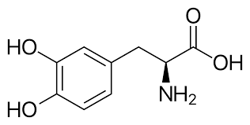 | 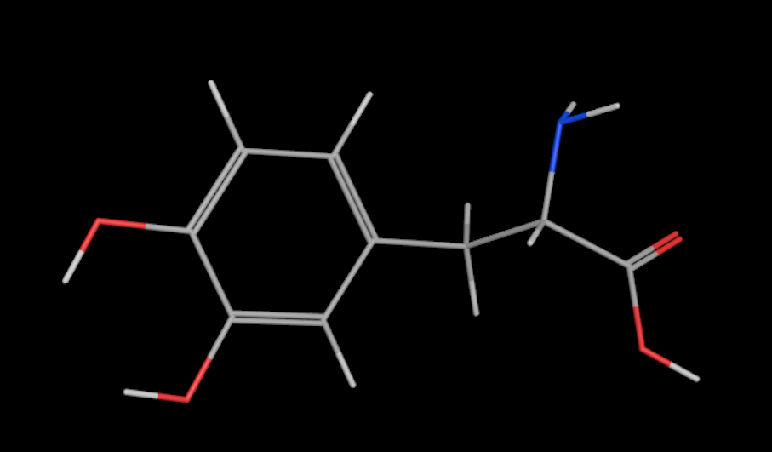
Figure 2: 2D structure for Levodopa | Figure 3: 3D structure for Levodopa using MOE

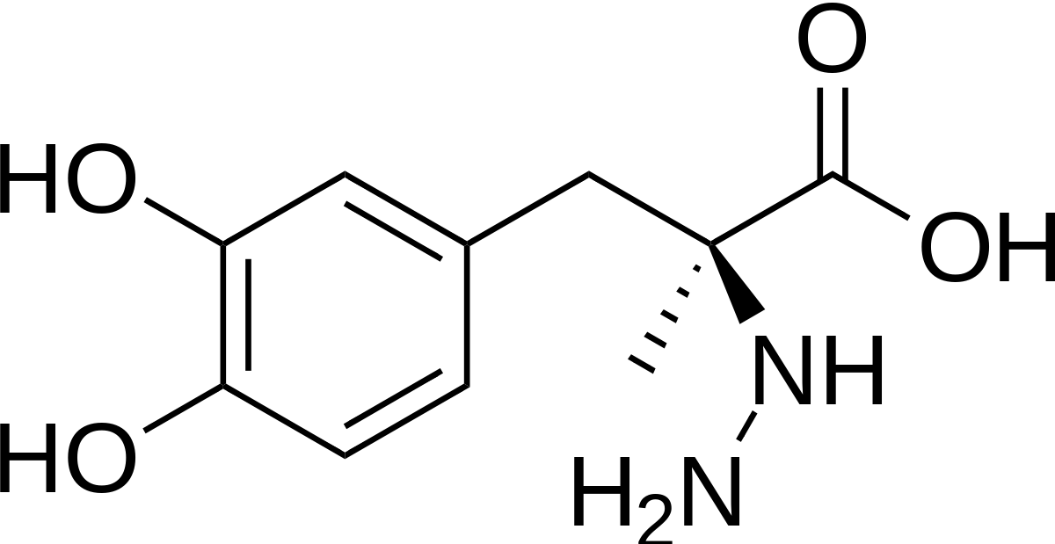 | 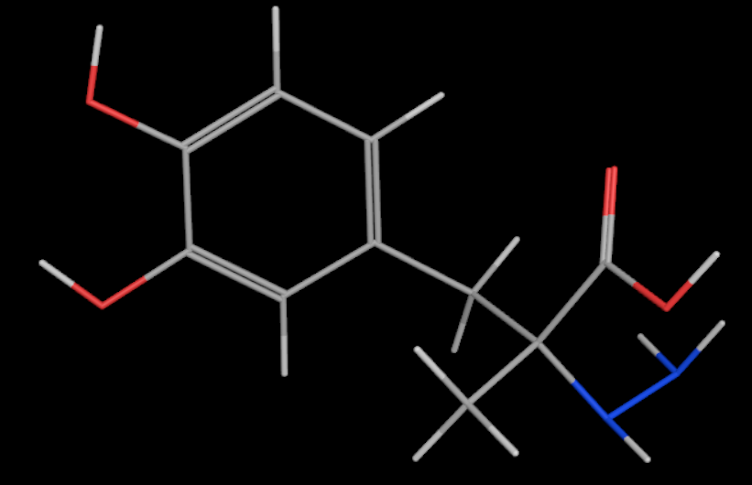
Figure 4: 2D structure for Carbidopa | Figure 5: 3D structure for Carbidopa using MOE
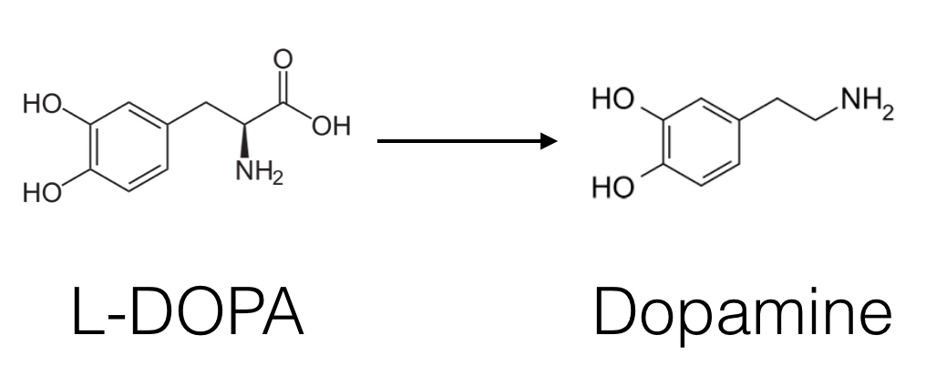
Figure 6: the conversion of L-dopa to dopamine

MAO-B Inhibitors:
One of the other strategies that can treat Parkinson’s disease is to allow the dopamine in the brain to hang around for longer, So a drug known as Monoamine Oxidase Type B inhibitors. Monoamine Oxidase Type B (MAO-B) is an enzyme that breaks down several chemicals in the brain, including dopamine. Monoamine Oxidase inhibitors that block these enzymes allowing more dopamine to be available to be used by the brain. This can modestly improve many motor symptoms of PD. In addition to using MAO-B inhibitors may reduce “off” time and extend “on” time. In addition, Animal studies have shown that MAO-B inhibitors can slow down PD progression and provide neuroprotection. The MAO-B inhibitor l-deprenyl, now marketed under the brand selegiline, was first studied in humans in the late 1980s in a clinical trial [14-18].
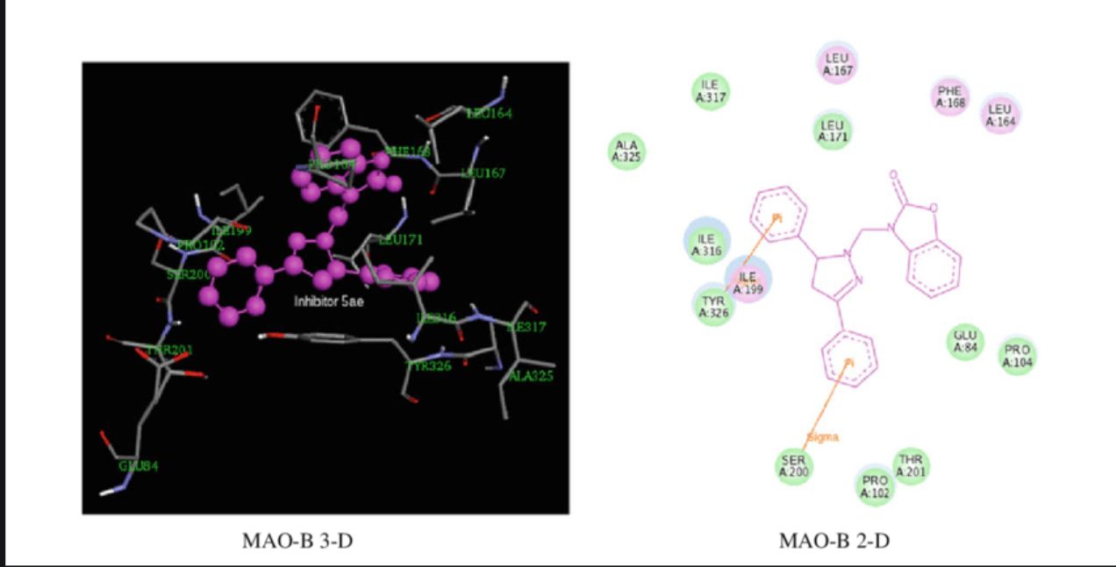
Figure 7 : Molecule docking of compound MAO-B generated with MOE; (A) the 3D picture of binding was depicted, (B) the 2D picture of binding was depicted.
Pharmacokinetic properties of MAO-B inhibitors : [19-26]
Name /properties | Rasagiline | Eldepryl or Selegiline Hcl
IUPAC name | ((1R)-N-prop-2-ynyl-2,3-dihydro-1H-inden-1-amine) | (methyl-[(2R)-1-phenylpropan-2-yl]-prop-2-ynyl azanium;chloride)
2D - Structure | 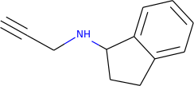 | 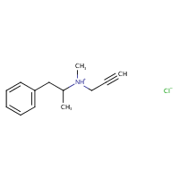
 | 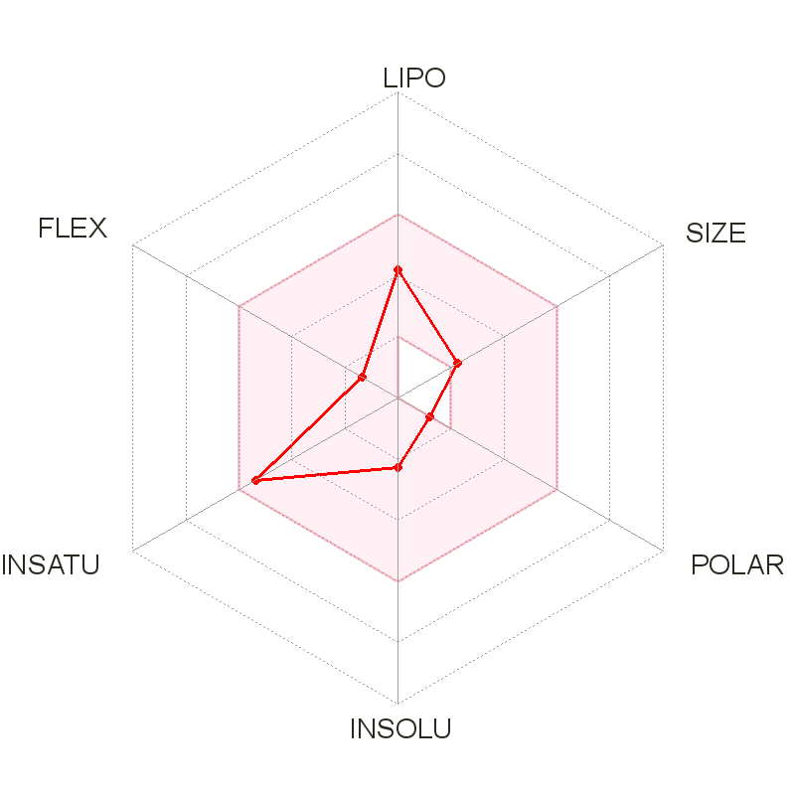 | 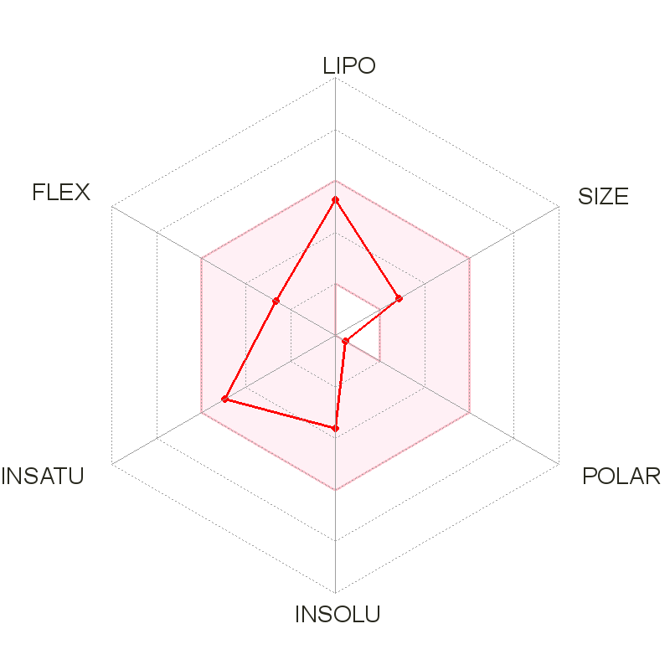
Canonical SMILES | C#CCNC1CCC2=CC=CC=C12 | CC(CC1=CC=CC=C1)[NH+](C)CC#C.[Cl-]
Molecular Weight | 171.243 g/mol | 223.74 g/mol
Formula | C12H13N | C13H18ClN
LogP | 1.8967 | -2.2305
Num. rotatable bonds | 2 | 4
Num. H-bond acceptors | 1 | 0
Num. H-bond donors | 1 | 1
Surface Area | 79.164 | 98.898
Water Solubility | Soluble | Soluble
BBB permean | yes | No
GI absorption | High | low
Lipinski | Yes; 0 violation | Yes; 0 violation
Intestinal absorption (human) | 94.671 | 97.719

Name /properties | Selegiline | Safinamide
IUPAC name | (2R)-N-methyl-1-phenyl-N-prop-2-enyl propan-2-amine | (methyl-[(2R)-1-phenylpropan-2-yl]-prop-2-ynyl azanium;chloride)
2D - Structure | 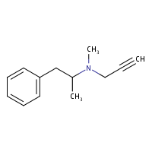 | 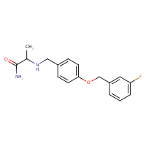
 | 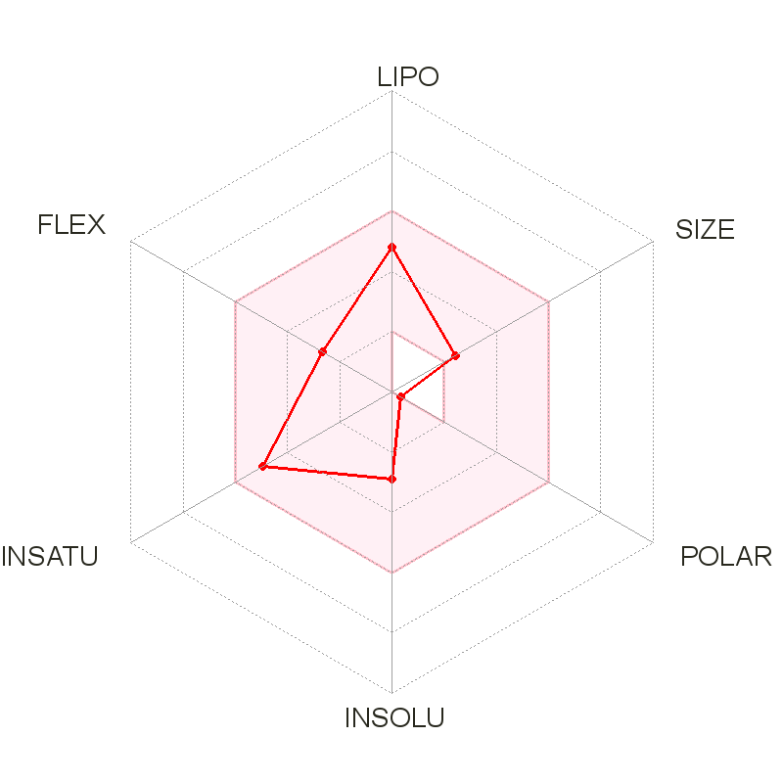 | 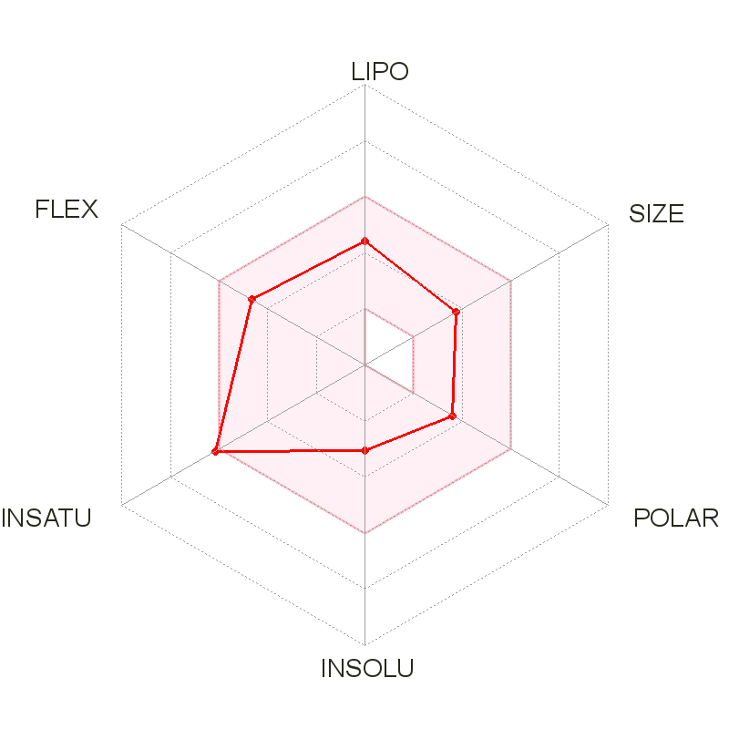
Canonical SMILES | CC(CC1=CC=CC=C1)N(C)CC#C | NC(=O)C(NCc1ccc(cc1)OCc1cccc(c1)F)C
Molecular Weight | 187.28 g/mol | 302.34 g/mol
Formula | C13H17N | C17H19FN2O2
LogP | 2.1826 | 2.3681
Num. rotatable bonds | 4 | 7
Num. H-bond acceptors | 1 | 3
Num. H-bond donors | 0 | 2
Surface Area | 86.745 | 128.644
Water Solubility | Soluble | Soluble
BBB permean | yes | yes
GI absorption | High | High
Lipinski | Yes; 0 violation | Yes; 0 violation
intestinal absorption (human) | 92.577 % | 92.459%

Suggestion modification using Bioisosterism:
Bioisosterism is one of the adopted approaches in drug design. Isosteres in its definition is the molecules having the same physical and chemical properties . While bioisosterism is referred to as a group of molecules might have the same or slightly different chemical activity, but have the same biological activity. Chemical isosteres are not necessary to have the same biological activity. For simplicity, bioisosterism can be classified as classical or non-classical . Classical is much similar to chemical isosteres where it can be applied on pseudo atoms, having same valency, ring equivalence where atoms in the ring can be replaced by similar atoms in number of electrons in the outer shell. The non-classical bioisosteres, on the other hand, are structurally different but are important to have similarity in some parameters such as pKa, lipophilicity as well as acting on the same receptor. The ultimate mission of bioisosterism in drug design is to achieve better potency, enhance selectivity, reduce toxicity, and enhance pharmacokinetics properties. Eldepryl or Selegiline Hcl has a very limited GI absorption decreasing its bioavailability as a result.Also, it does not pass the blood brain barrier, BBB. So, In this report, Classical bioisosteres approach is used to overcome those deficits.
Method:
1- Determination of the structures necessary for inhibition (pharmacophore) using Moe pharmacophore query modling on Moe programm by the flexible alignment of all the inhibitors, then build the pharmacophore query based on the result of the lowest S score flexible alignment. These features most probably are essential for biological activity (inhibition of MAO-B enzyme).

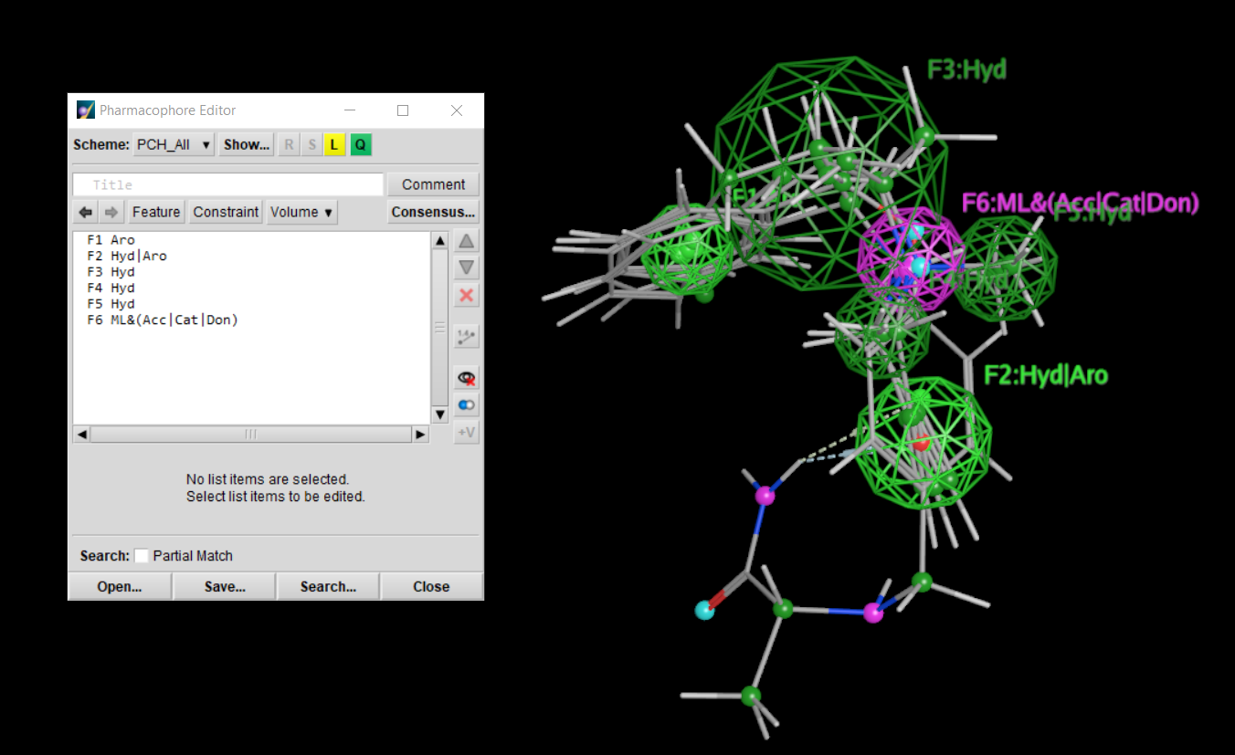
Figure 8: pharmacophore using MOE.
2- After identifying the essential structures for inhibition, The Swiss BIOisostere database was used to generate bioisosteres to the six main fragments that lead to the inhibition that can increase GI absorption and BBB Permian the Eldepryl inhibitor.
First suggestion:
The classical bioisosteres approach enables the Eldepryl inhibitors to pass the blood-brain barrier through the Periodic table isostere. The terminal chloride group is replaced with Phosphorus (P)
Name /properties | First suggestion
2D - Structure | 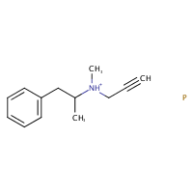
 | 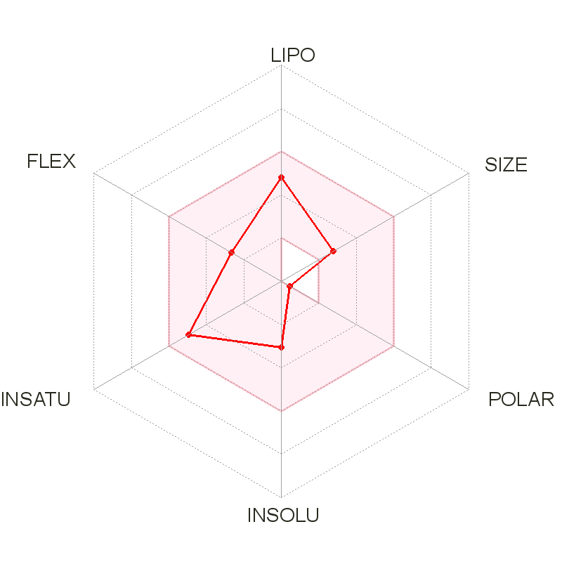
Canonical SMILES | CC([NH+](CC#C)C)Cc1ccccc1.[P]
Molecular Weight | 219.26 g/mol
Formula | C13H18NP
LogP | 1.6267
Surface Area | 96.496
Water Solubility | Soluble
BBB permean | yes
GI absorption | low
Lipinski | Yes; 0 violation
Intestinal absorption (human) | 96.816

Second suggestion:
The classical compound’s GI absorption bioisosteres approach is used to increase the GI absorption of the first suggested compound as the substituent methyl group is replaced with Fluoride (F).

Name /properties | Second suggestion
2D - Structure | 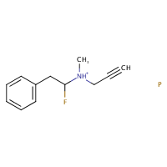
 | 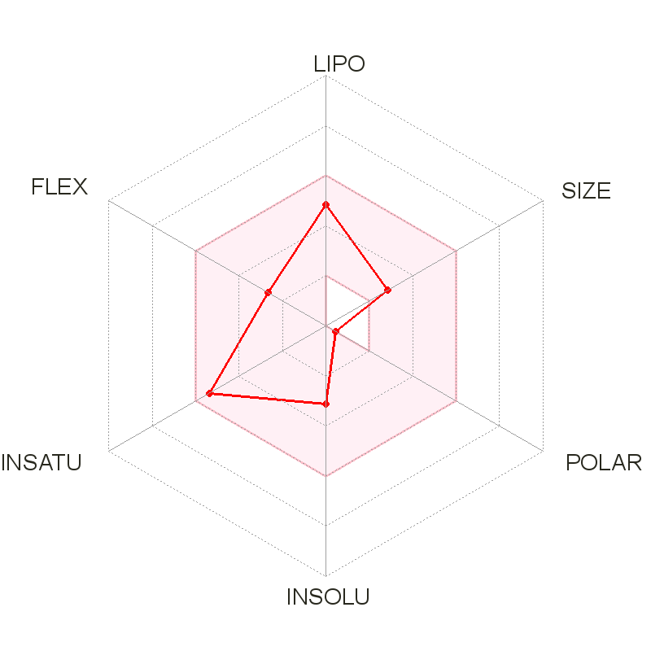
Canonical SMILES | FC([NH+](CC#C)C)Cc1ccccc1.[P]
Molecular Weight | 223.23 g/mol
Formula | C12H15FNP
LogP | 1.5338
Surface Area | 94.296
Water Solubility | Soluble
BBB permean | Yes
GI absorption | High
Lipinski | Yes; 0 violation
Intestinal absorption (human) | 96.086
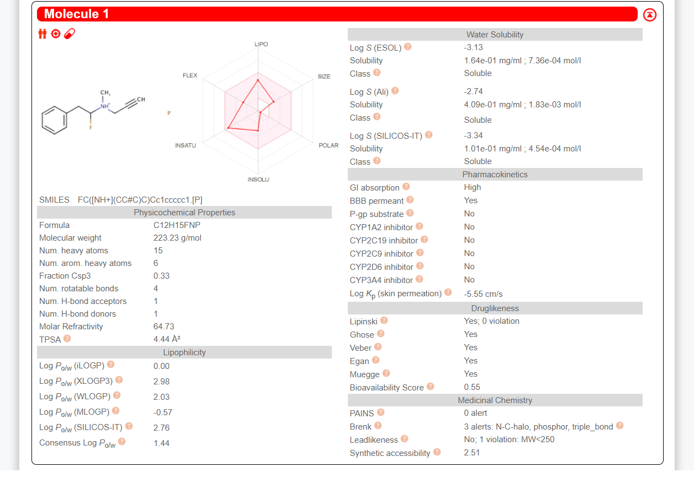
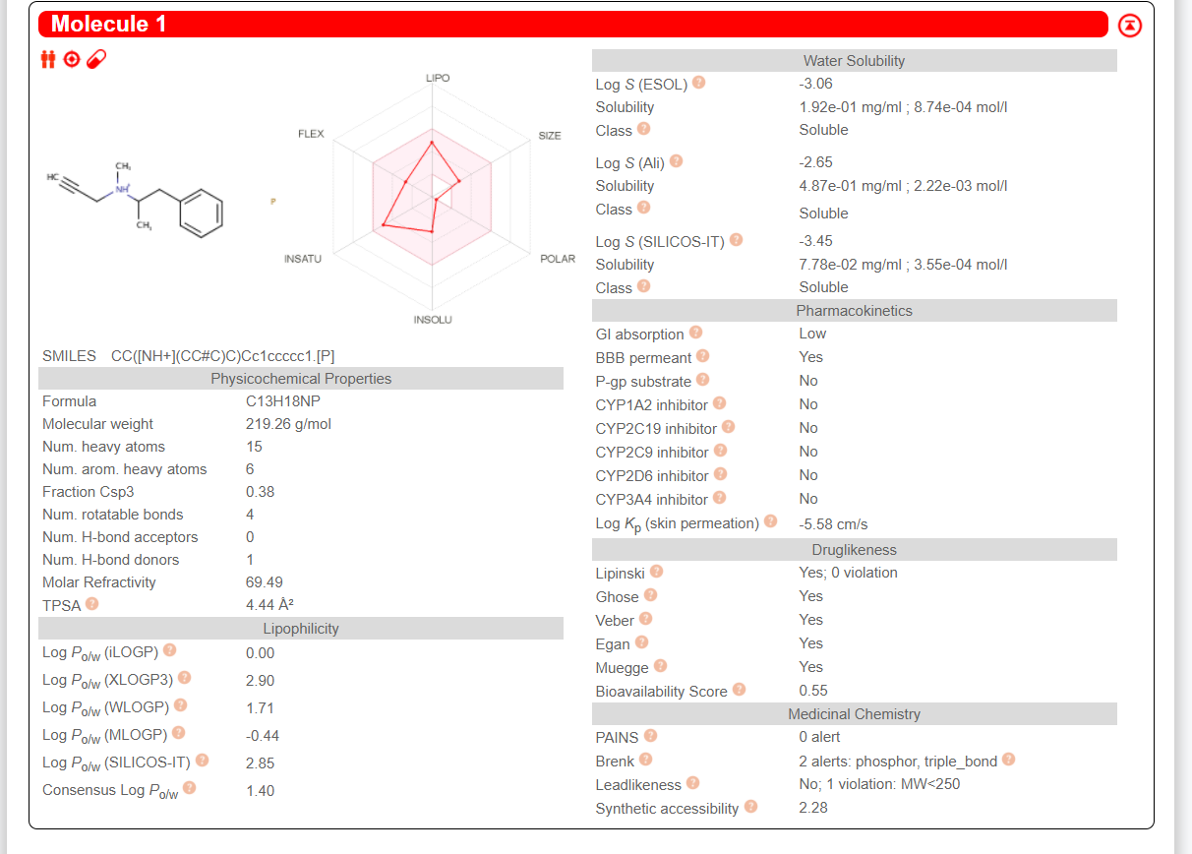

References:
[1] A. Kouli, K. M. Torsney, and W.-L. Kuan, “Parkinson’s Disease: Etiology, Neuropathology, and Pathogenesis,” in Parkinson’s Disease: Pathogenesis and Clinical Aspects, 2018.
[2] G. DeMaagd and A. Philip, “Parkinson's Disease and Its Management: Part 1: Disease Entity, Risk Factors, Pathophysiology, Clinical Presentation, and Diagnosis,” P & T: a peer-reviewed journal for formulary management, Aug-2015. [Online]. Available: https://www.ncbi.nlm.nih.gov/pmc/articles/PMC4517533/#b6-ptj4008504. [Accessed: 09-Jan-2021].
[3] J. A. Driver, G. Logroscino, J. M. Gaziano, and T. Kurth, “Incidence and remaining lifetime risk of Parkinson disease in advanced age,” Neurology, vol. 72, no. 5, pp. 432–438, 2009.
[4] L. M. D. Lau and M. M. Breteler, “Epidemiology of Parkinson's disease,” The Lancet Neurology, vol. 5, no. 6, pp. 525–535, 2006.
[5] I. N. Miller and A. Cronin-Golomb, “Gender differences in Parkinson's disease: Clinical characteristics and cognition,” Movement Disorders, vol. 25, no. 16, pp. 2695–2703, 2010.
[6] “Parkinson's Disease.” [Online]. Available: https://www.nia.nih.gov/health/parkinsons-disease#:~:text=Parkinson's%20disease%20is%20a%20brain,have%20difficulty%20walking%20and%20talking. [Accessed: 10-Jan-2021].
[7] Z. Huang, R. D. L. Fuente-Fernández, and A. J. Stoessl, “Etiology of Parkinson's Disease,” Canadian Journal of Neurological Sciences / Journal Canadien des Sciences Neurologiques, vol. 30, no. S1, 2003.
[8] T. Bordia, M. Mcgregor, R. L. Papke, M. W. Decker, J. M. Mcintosh, and M. Quik, “The α7 nicotinic receptor agonist ABT-107 protects against nigrostriatal damage in rats with unilateral 6-hydroxydopamine lesions,” Experimental Neurology, vol. 263, pp. 277–284, 2015.
[9] R. Srinivasan, B. M. Henley, B. J. Henderson, T. Indersmitten, B. N. Cohen, C. H. Kim, S. Mckinney, P. Deshpande, C. Xiao, and H. A. Lester, “Smoking-Relevant Nicotine Concentration Attenuates the Unfolded Protein Response in Dopaminergic Neurons,” Journal of Neuroscience, vol. 36, no. 1, pp. 65–79, 2016.
[10] Naoi, M., Maruyama, W., & Shamoto-Nagai, M. (2020). Rasagiline and selegiline modulate mitochondrial homeostasis, intervene apoptosis system and mitigate α-synuclein cytotoxicity in disease-modifying therapy for Parkinson’s disease. Journal of Neural Transmission, 127(2), 131-147.
[11] Müller Thomas and H. Przuntek, Diagnosis and treatment of Parkinson's disease: state of the art. Wien: Springer, 1999.
[12][Online].Available:https://www.nhs.uk/conditions/parkinsons-disease/treatment/#:~:text=your%20needs%20change.-,Levodopa,and%20nerves%20that%20control%20movement. [Accessed: 10-Jan-2021].
[13] “Basics of levodopa,” Parkinson's Therapeutics, 22-Apr-2018. [Online]. Available: https://parkinsons-therapeutics.org/basics-of-levodopa/. [Accessed: 10-Jan-2021].
[14] L. Dezsi and L. Vecsei, “Monoamine Oxidase B Inhibitors in Parkinson's Disease,” CNS & Neurological Disorders - Drug Targets, vol. 16, no. 4, 2017.
[15] P. Foley, M. Gerlach, M. Youdim, and P. Riederer, “MAO-B inhibitors: multiple roles in the therapy of neurodegenerative disorders?,” Parkinsonism & Related Disorders, vol. 6, no. 1, pp. 25–47, 2000.
[16] M. Huang, S.-S. Xie, N. Jiang, J.-S. Lan, L.-Y. Kong and X.-B. Wang, “Multifunctional coumarin derivatives: Monoamine oxidase B (MAO-B) inhibition, anti-β-amyloid (Aβ) aggregation and metal chelation properties against Alzheimer’s disease,” Bioorganic & Medicinal Chemistry Letters, vol. 25, no. 3, pp. 508–513, 2015.
[17] W. Li, X. Yang, Q. Song, Z. Cao, Y. Shi, Y. Deng, and L. Zhang, “Pyridoxine-resveratrol hybrids as novel inhibitors of MAO-B with antioxidant and neuroprotective activities for the treatment of Parkinson’s disease,” Bioorganic Chemistry, vol. 97, p. 103707, 2020.
[18] C. Binda, M. Li, F. Hubalek, N. Restelli, D. E. Edmondson, and A. Mattevi, “Insights into the mode of inhibition of human mitochondrial monoamine oxidase B from high-resolution crystal structures,” Proceedings of the National Academy of Sciences, vol. 100, no. 17, pp. 9750–9755, 2003.
[19] “MAO-B Inhibitors,” Parkinson's Foundation. [Online]. Available: https://www.parkinson.org/Understanding-Parkinsons/Treatment/Prescription-Medications/MAO-B-Inhibitors. [Accessed: 10-Jan-2021].
[20] “Monoamine Oxidase B (MAO-B) Inhibitors,” Parkinson's Disease Clinic and Research Center. [Online]. Available: https://pdcenter.ucsf.edu/monoamine-oxidase-b-mao-b-inhibitors. [Accessed: 10-Jan-2021].
[21] “Selegiline hydrochloride,” National Center for Biotechnology Information. PubChem Compound Database. [Online]. Available: https://pubchem.ncbi.nlm.nih.gov/compound/Selegiline-hydrochloride#section=Computed-Properties. [Accessed: 10-Jan-2021].
[22] Eldepryl, Zelapar (selegiline) dosing, indications, interactions, adverse effects, and more, 28-Sep-2019. [Online]. Available: https://reference.medscape.com/drug/eldepryl-zelapar-selegiline-343052. [Accessed: 10-Jan-2021].
[23] “Eldepryl,” Eldepryl | MIMS online. [Online]. Available: https://www.mims.co.uk/drugs/central-nervous-system/parkinson-s-disease-parkinsonism/eldepryl. [Accessed: 10-Jan-2021].
[24] “Rasagiline: MedlinePlus Drug Information,” MedlinePlus. [Online]. Available: https://medlineplus.gov/druginfo/meds/a606017.html. [Accessed: 10-Jan-2021].
[25] “Azilect Oral : Uses, Side Effects, Interactions, Pictures, Warnings & Dosing,” WebMD. [Online]. Available: https://www.webmd.com/drugs/2/drug-144443/azilect-oral/details. [Accessed: 10-Jan-2021].
[26] H. M. Ishiki, J. M. B. Filho, M. S. D. Silva, M. T. Scotti, and L. Scotti, “Computer-aided Drug Design Applied to Parkinson Targets,” Current Neuropharmacology, vol. 16, no. 6, pp. 865–880, 2018.

